**LAB OUTPUTS FOR CLOUD COMPUTING AND BIG ANALYTICS .**

**SUBJECT CODE & NAME: CSA1592-CLOUD COMPUTING AND BIG ANALYTICS FOR WEB SERVICES**

**SERIAL NUMBER :07**

**NAME:CH.DURGA NARENDRA**

**REGISTER NUMBER:192211285**

**EXP NO 1: CREATE A SIMPLE CLOUD SOFTWARE APPLICATION AND PROVIDE IT AS A SERVICE USING ANY CLOUD SERVICE PROVIDER TO DEMONSTRATE SOFTWARE AS A SERVICE (SAAS).**

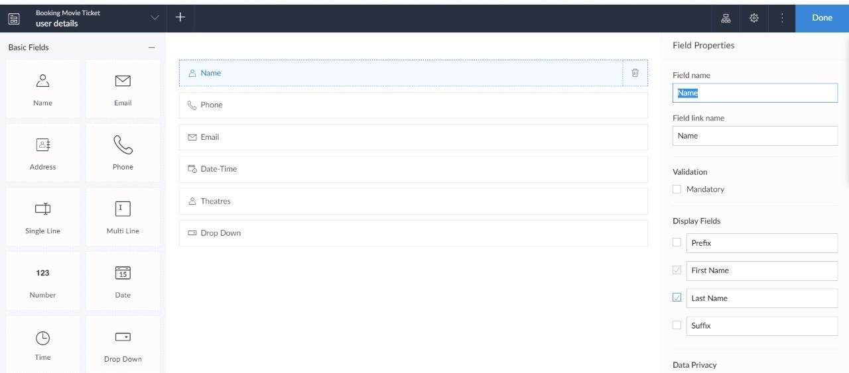

**EXP NO 2: CREATE A SIMPLE CLOUD SOFTWARE APPLICATION FOR FLIGHT RESERVATION SYSTEM USING ANY CLOUD SERVICE PROVIDER TO DEMONSTRATE SAAS**.

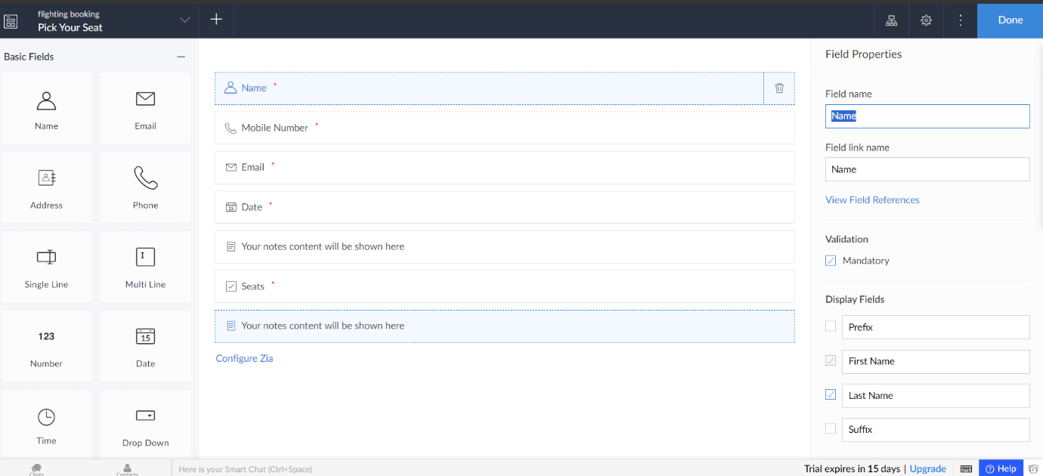

**EXP NO 3: CREATE A SIMPLE CLOUD SOFTWARE APPLICATION FOR PROPERTY BUYING & RENTAL PROCESS (IN CHENNAI CITY) USING ANY CLOUD SERVICE PROVIDER TO DEMONSTRATE SAAS.**

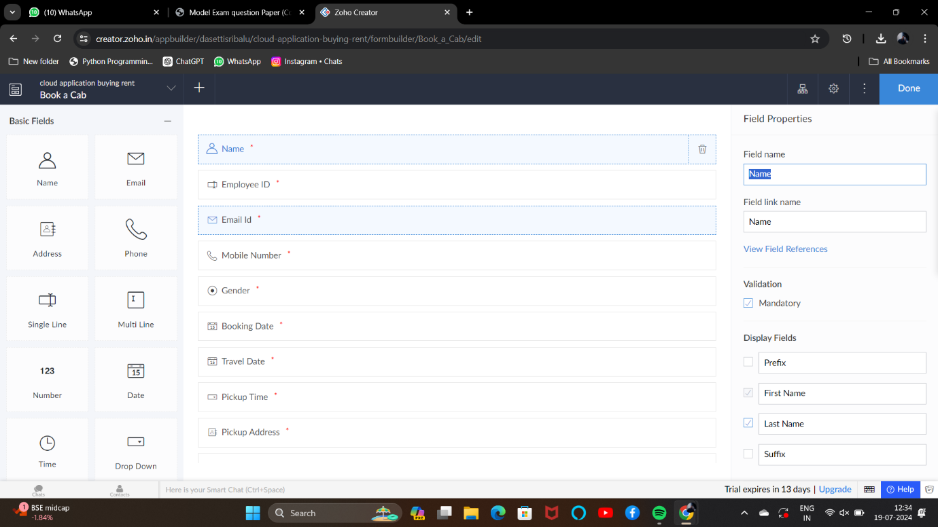

**EXP NO 4: CREATE A SIMPLE CLOUD SOFTWARE APPLICATION FOR CAR BOOKING RESERVATION SYSTEM USING ANY CLOUD SERVICE PROVIDER TO DEMONSTRATE SAAS.**



**EXP NO 5: CREATE A SIMPLE CLOUD SOFTWARE APPLICATION FOR LIBRARY BOOK RESERVATION SYSTEM FOR SIMATS LIBRARY USING ANY CLOUD SERVICE PROVIDER TO DEMONSTRATE SAAS**



**EXP NO 6: CREATE A SIMPLE CLOUD SOFTWARE APPLICATION FOR PRODUCT SELLING USING ANY CLOUD SERVICE PROVIDER TO DEMONSTRATE SAAS.**



**EXP NO 7: DEMONSTRATE VIRTUALIZATION BY INSTALLING TYPE-2 HYPERVISOR IN YOUR DEVICE, CREATE AND CONFIGURE VM IMAGE WITH A HOST OPERATING SYSTEM (EITHER WINDOWS/LINUX).**

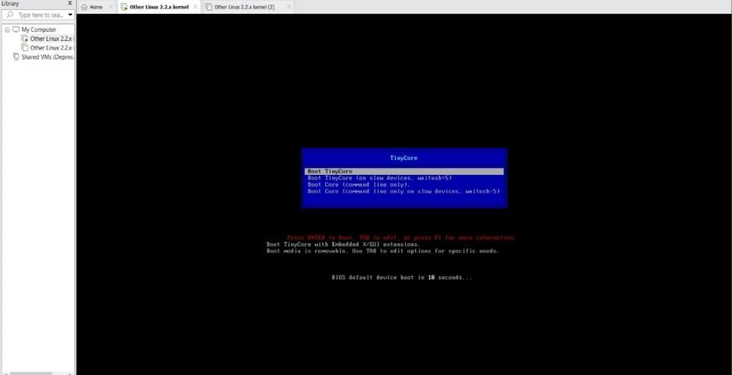

**EXPNO 8: CREATE A VIRTUAL MACHINE WITH 1 CPU, 2GB RAM AND 15GB STORAGE DISK USING A TYPE 2 VIRTUALIZATION SOFTWARE.**

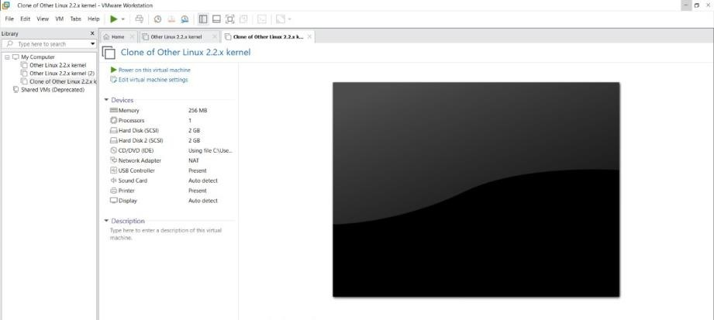

**EXP 9: CREATE A VIRTUAL HARD DISK AND ALLOCATE THE STORAGE USING VM WARE WORKSTATION.**

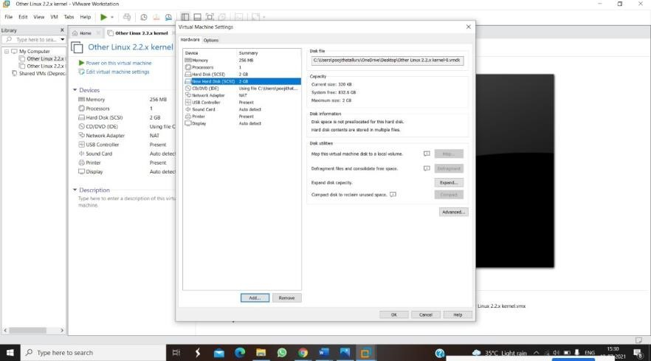

**EXPNO 10: CREATE A SNAPSHOT OF A VM AND TEST IT BY LOADING THE PREVIOUS VERSION/CLONED VM**

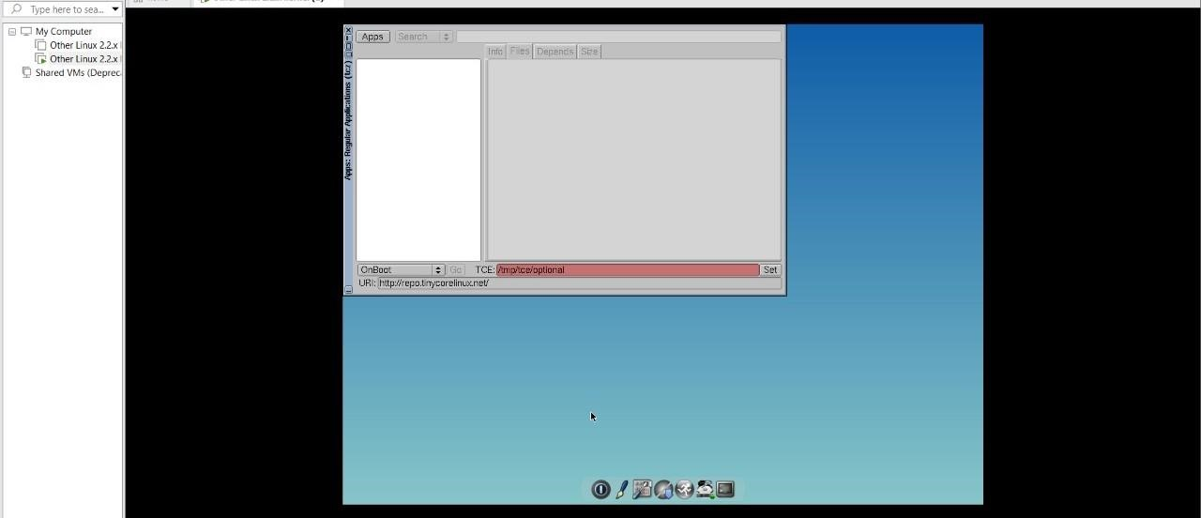

**EXPNO 11: CREATE A CLONING OF A VM AND TEST IT BY LOADING THE PREVIOUS VERSION/CLONED VM.**

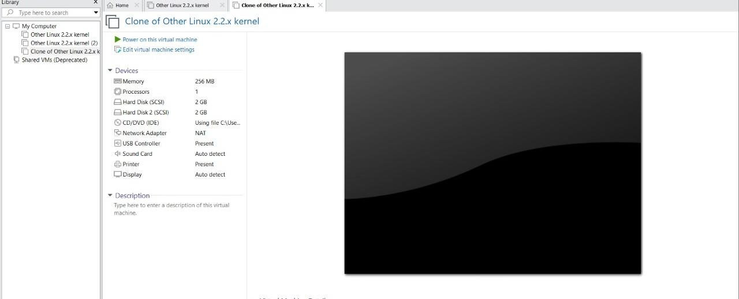

**EXP 12: CHANGE HARDWARE COMPATIBILITY OF A VM (EITHER BY CLONE/CREATE NEW ONE) WHICH IS ALREADY CREATED AND CONFIGURED.**



**EXP13. DEMONSTRATE INFRASTRUCTURE AS A SERVICE (IAAS) BY CREATING A VIRTUAL MACHINE USING A PUBLIC CLOUD SERVICE PROVIDER (AZURE), CONFIGURE WITH REQUIRED MEMORY AND CPU.**



**EXP14** Demonstrate Infrastructure as a Service (IaaS) by creating a Virtual Machine using a Public Cloud Service Provider (Azure), configure with required memory and CPU.



**EXP15.CREATE A SIMPLE WEB SITE USING ANY PUBLIC CLOUD SERVICE PROVIDER**

**(AZURE/GCP/AWS) AND CHECK THE PUBLIC ACCESSIBILITY OF THE STORED FILE TO**

**DEMONSTRATE STORAGE AS A SERVICE**

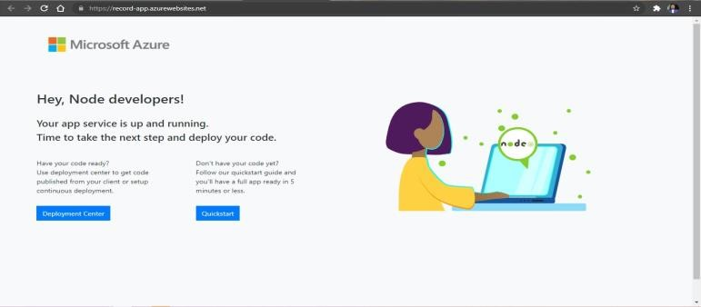

**EXP 16 .Demonstrate Platform as a Service (PaaS) create and configure a new VM Image in any Public Cloud Service Provider**



**EXP 17 .DEMONSTRATE INFRASTRUCTURE AS A SERVICE(IAAS) BY CREATING A VIRTUAL MACHINE USING A PUBLIC CLOUD SERVICE PROVIDER(AZURE/GCP/AWS) CONFIGURE WITH MINIMUM CPU, RAM AND STORAGE AND LAUNCH THE VM IMAGE.**

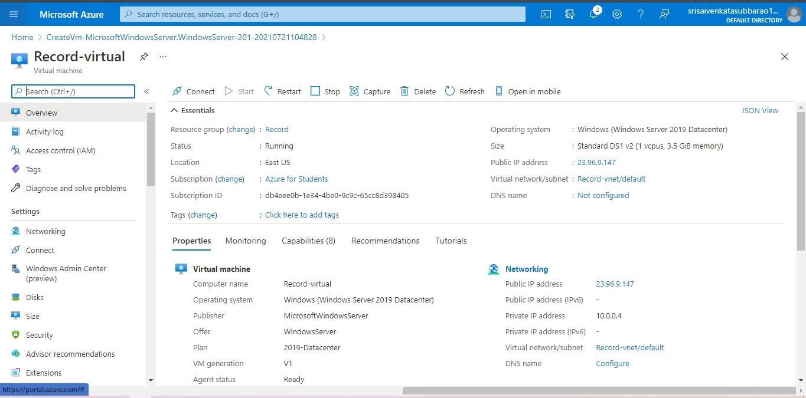

**EXP 18.Demonstrate Storage as a Service (SaaS) create and configure a new VM Image in any Public Cloud Service Provider**



**EXP19.CREATE A STORAGE SERVICE USING ANY PUBLIC CLOUD SERVICE PROVIDER (AZURE/GCP/AWS)**

**AND CHECK THE PUBLIC ACCESSIBILITY OF THE STORED FILE TO DEMONSTRATE STORAGE AS A SERVICE.**

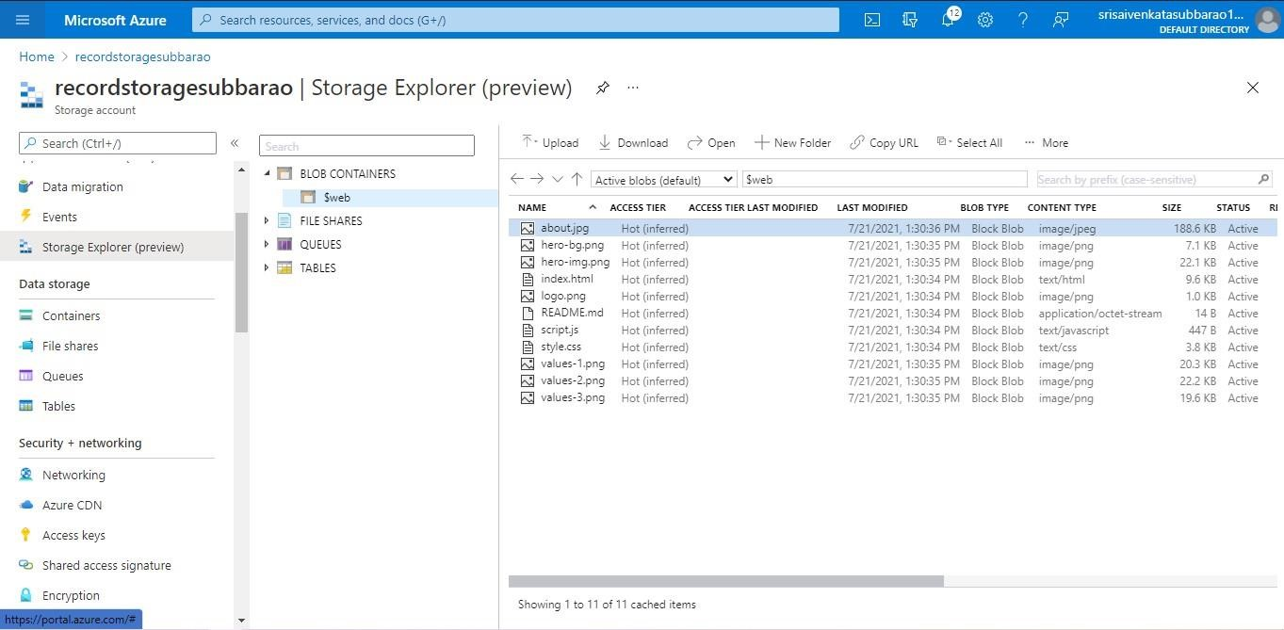

**EXP20.CREATE A SQL STORAGE SERVICE AND PERFORM A BASIC QUERY USING ANY PUBLIC**

**CLOUD SERVICE PROVIDER (AZURE/GCP/AWS) TO DEMONSTRATE DATABASE AS A SERVICE (DAAS)**

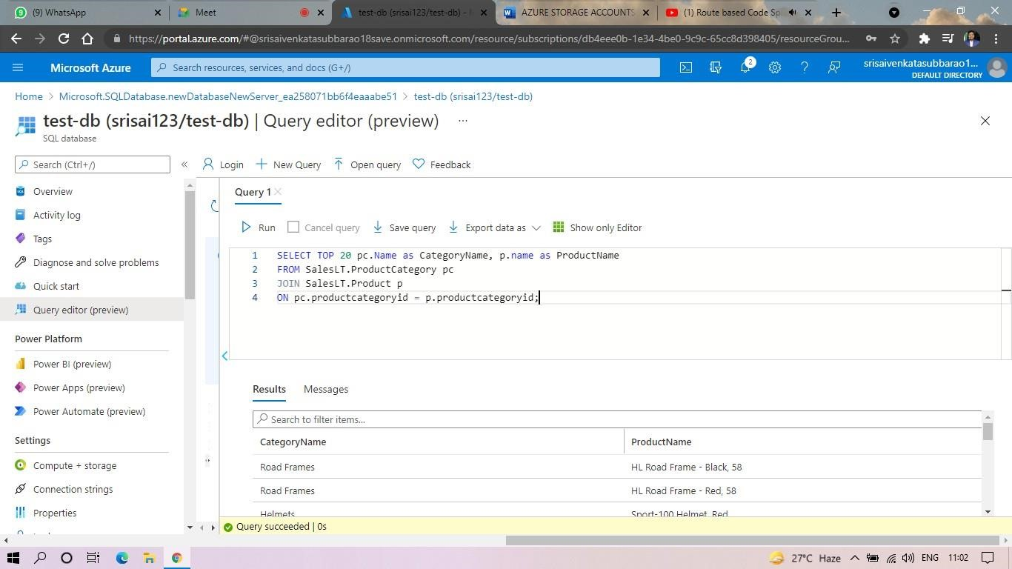

EXP-21.Create a SQL storage service and perform a basic query using any Public Cloud Service Provider (Azure/GCP/AWS) to demonstrate Database as a Service (DaaS)



EXP-22.Perform the basic configuration setup for installing HADOOP 2.x like creating the HDUSER and SSH localhost

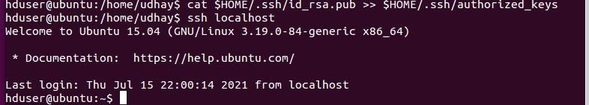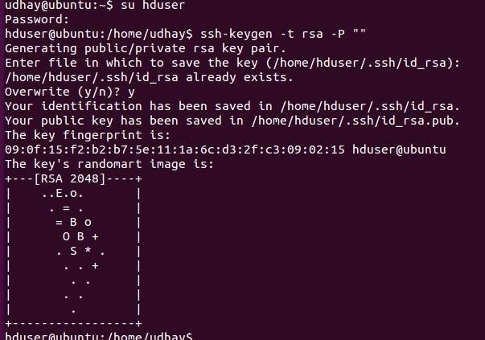

EXP-23. Install Hadoop 2.x and configure the Name Node and Data Node.

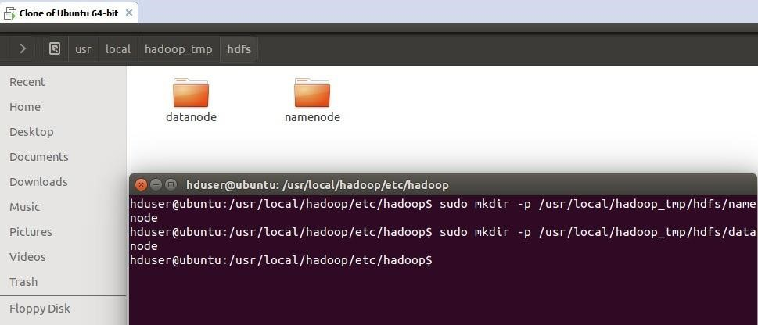

EXP-24. Launch the Hadoop 2.x and test the Map-Reduce Platform with Hadoop.

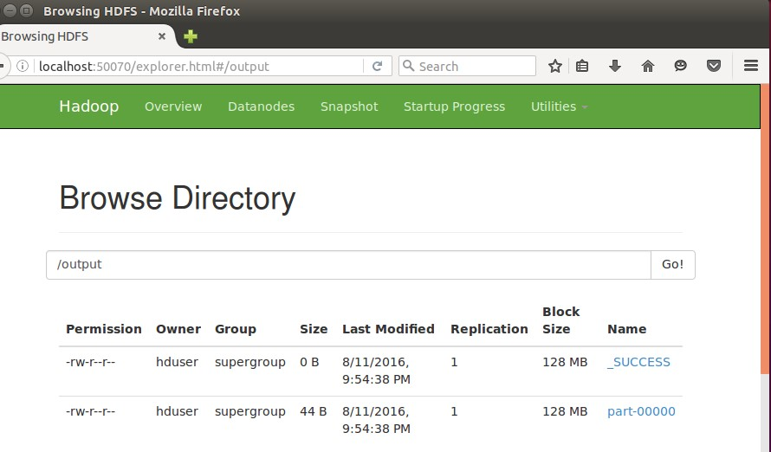

EXP-25. Launch the Hadoop 2.x and perform Map-Reduce program For a word count problem

